Side
# Source: AI Source: Provided by: [Data Path: Persons Table -> ID Column: 1, Name_En Column: Motasem Essam] -> From: [ChatGPT] on [7/25/2026]
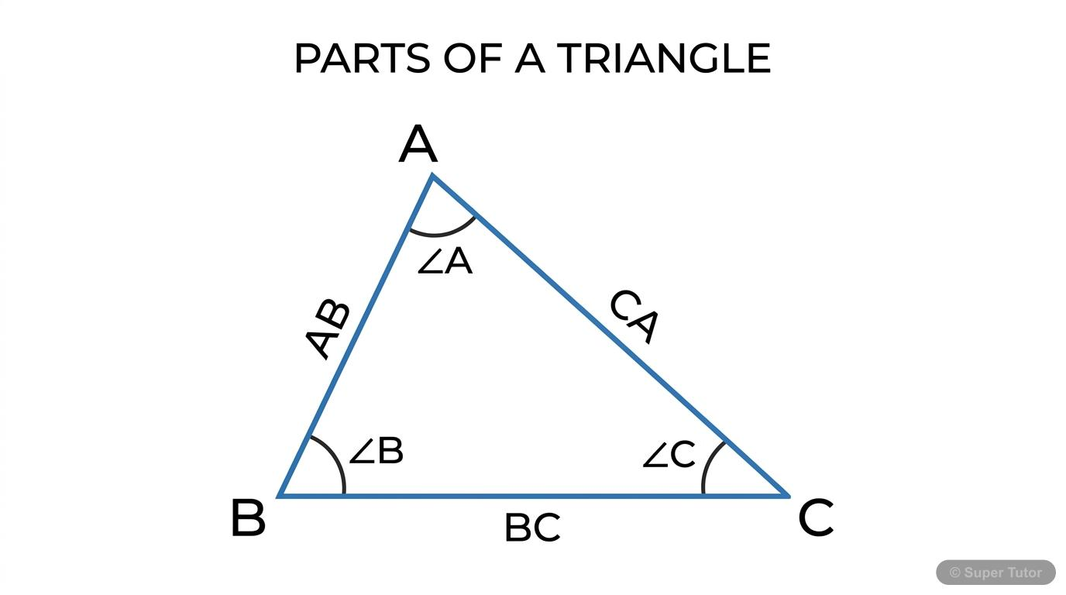
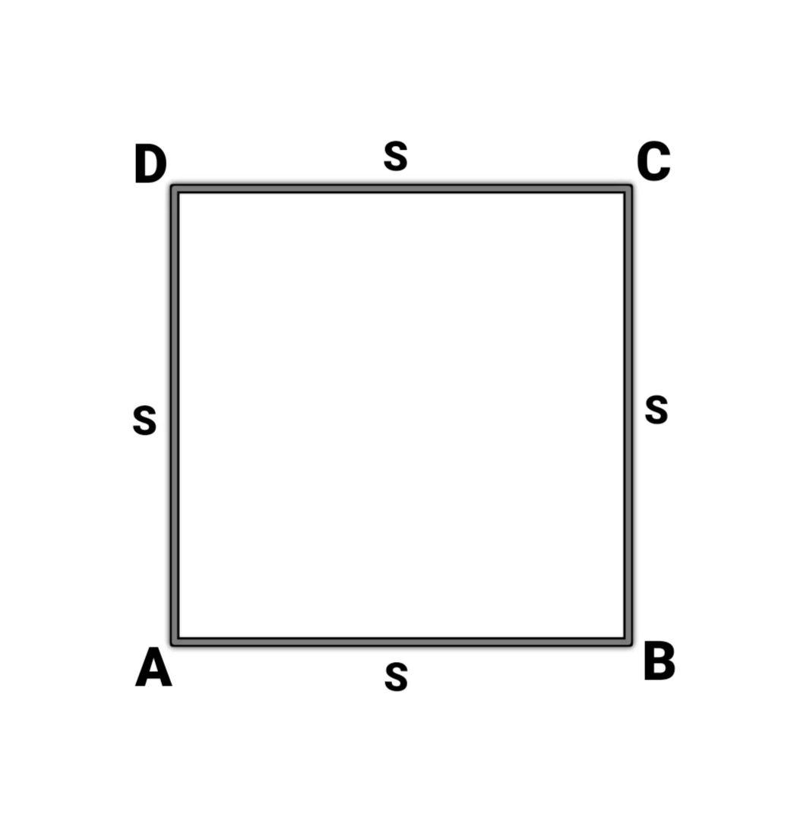
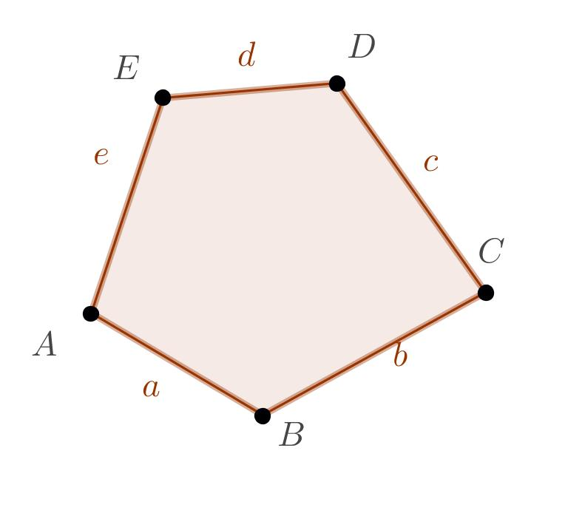
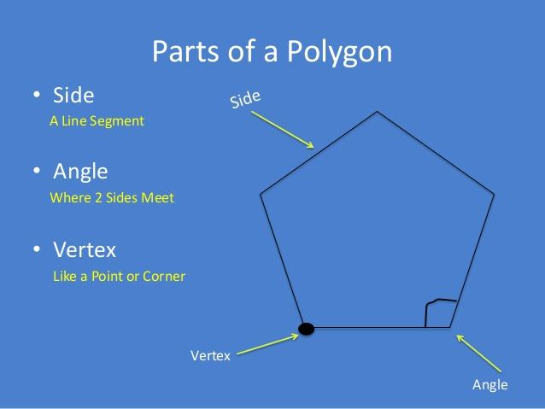
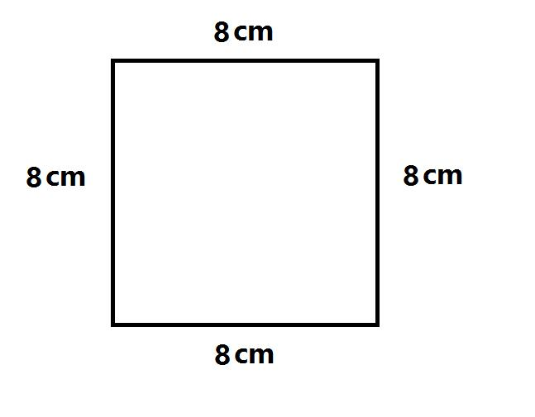
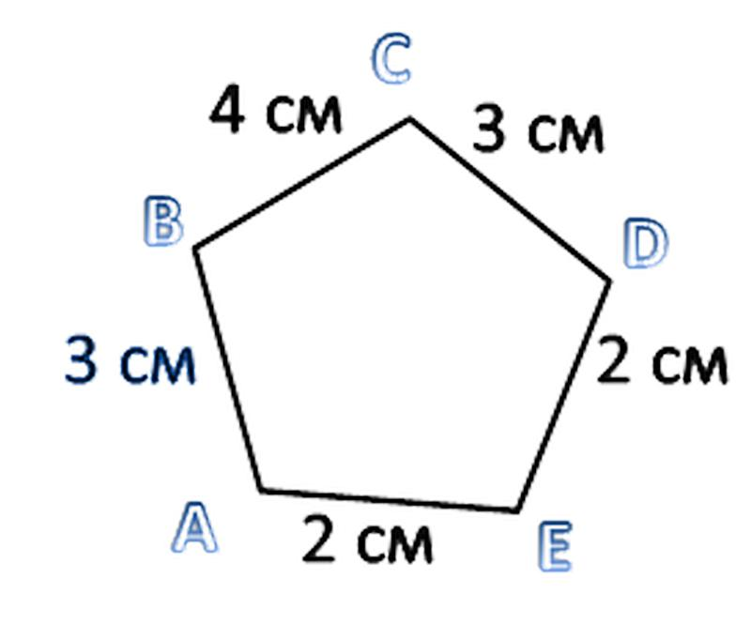

Definition
# Source: AI Source: Provided by: [Data Path: Persons Table -> ID Column: 1, Name_En Column: Motasem Essam] -> From: [ChatGPT] on [7/25/2026]
A Side is a straight line segment that forms part of the boundary of a polygon. Each side connects two consecutive vertices of the polygon.
Sides are one of the fundamental components of polygonal shapes and determine the figure's size, perimeter, and many of its geometric properties.

Characteristics
# Source: AI Source: Provided by: [Data Path: Persons Table -> ID Column: 1, Name_En Column: Motasem Essam] -> From: [ChatGPT] on [7/25/2026]
A side:
- Is a straight line segment.
- Connects two adjacent vertices.
- Forms part of the polygon's boundary.
- Has measurable length.
- Has no thickness.
- Together with the other sides, encloses the polygon's interior region.

Illustration
# Source: AI Source: Provided by: [Data Path: Persons Table -> ID Column: 1, Name_En Column: Motasem Essam] -> From: [ChatGPT] on [7/25/2026]
Triangle
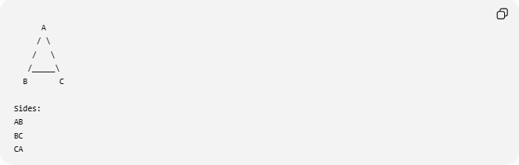
A
/ \
/ \
/_____\
B C

Sides:
AB
BC
CA

Square
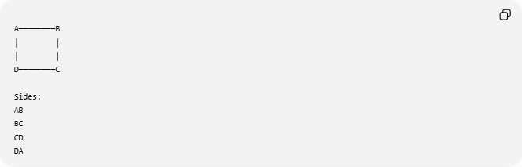
A────────B
│ │
│ │
D────────C

Sides:
AB
BC
CD
DA

Mathematical Representation
# Source: AI Source: Provided by: [Data Path: Persons Table -> ID Column: 1, Name_En Column: Motasem Essam] -> From: [ChatGPT] on [7/25/2026]
A side joining vertices
$$A$$
and
$$B$$
is represented by the line segment:
$$\overline{AB}$$
Examples:
Triangle:
$$\overline{AB},\overline{BC},\overline{CA}$$
Rectangle:
$$\overline{AB},\overline{BC},\overline{CD},\overline{DA}$$

Number of Sides
# Source: AI Source: Provided by: [Data Path: Persons Table -> ID Column: 1, Name_En Column: Motasem Essam] -> From: [ChatGPT] on [7/25/2026]
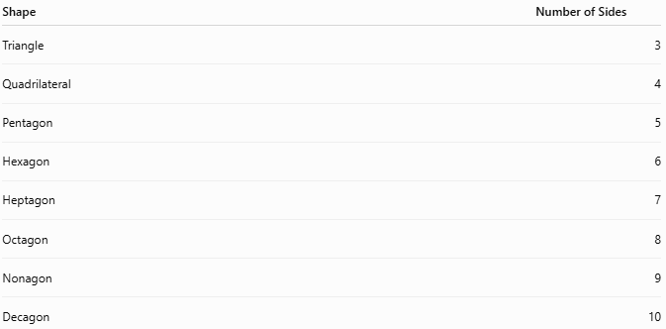
Shape | Number of Sides
Triangle | 3
Quadrilateral | 4
Pentagon | 5
Hexagon | 6
Heptagon | 7
Octagon | 8
Nonagon | 9
Decagon | 10

Equal and Unequal Sides

Equal Sides
# Source: AI Source: Provided by: [Data Path: Persons Table -> ID Column: 1, Name_En Column: Motasem Essam] -> From: [ChatGPT] on [7/25/2026]
Shapes with equal side lengths:
- Square
- Equilateral Triangle
- Regular Pentagon
- Regular Hexagon

Unequal Sides
# Source: AI Source: Provided by: [Data Path: Persons Table -> ID Column: 1, Name_En Column: Motasem Essam] -> From: [ChatGPT] on [7/25/2026]
Shapes with sides of different lengths:
- Scalene Triangle
- Irregular Quadrilateral
- Irregular Polygon

Adjacent Sides
# Source: AI Source: Provided by: [Data Path: Persons Table -> ID Column: 1, Name_En Column: Motasem Essam] -> From: [ChatGPT] on [7/25/2026]
Two sides that share a common vertex are called adjacent sides.
Example:
In a rectangle:
- AB and BC are adjacent.
- BC and CD are adjacent.

Opposite Sides
# Source: AI Source: Provided by: [Data Path: Persons Table -> ID Column: 1, Name_En Column: Motasem Essam] -> From: [ChatGPT] on [7/25/2026]
Some polygons have opposite sides.
Example:
Rectangle:
- AB is opposite CD.
- BC is opposite AD.

Real-World Examples
# Source: AI Source: Provided by: [Data Path: Persons Table -> ID Column: 1, Name_En Column: Motasem Essam] -> From: [ChatGPT] on [7/25/2026]
Sides appear in:
- Building walls.
- Window frames.
- Books.
- Tables.
- Picture frames.
- Floor tiles.
- Road signs.
- Boxes.
- Football fields.
- Computer icons.

Applications
# Source: AI Source: Provided by: [Data Path: Persons Table -> ID Column: 1, Name_En Column: Motasem Essam] -> From: [ChatGPT] on [7/25/2026]
Sides are used in:
- Plane Geometry
- Coordinate Geometry
- Analytic Geometry
- Engineering
- Architecture
- Surveying
- CAD (Computer-Aided Design)
- Computer Graphics
- GIS (Geographic Information Systems)
- Robotics

Advantages
# Source: AI Source: Provided by: [Data Path: Persons Table -> ID Column: 1, Name_En Column: Motasem Essam] -> From: [ChatGPT] on [7/25/2026]
Studying sides helps to:
- Compute perimeter.
- Classify polygons.
- Determine congruence.
- Analyze similarity.
- Solve geometric constructions.

Limitations
# Source: AI Source: Provided by: [Data Path: Persons Table -> ID Column: 1, Name_En Column: Motasem Essam] -> From: [ChatGPT] on [7/25/2026]
The concept of a side:
- Applies primarily to polygonal shapes.
- Does not apply directly to figures with entirely curved boundaries, such as circles or ellipses.

Comparison with Related Concepts
# Source: AI Source: Provided by: [Data Path: Persons Table -> ID Column: 1, Name_En Column: Motasem Essam] -> From: [ChatGPT] on [7/25/2026]
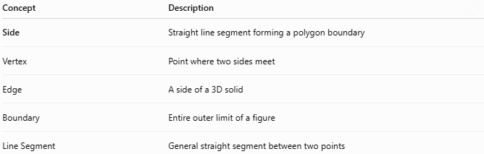
Concept | Description
Side | Straight line segment forming a polygon boundary
Vertex | Point where two sides meet
Edge | A side of a 3D solid
Boundary | Entire outer limit of a figure
Line Segment | General straight segment between two points

Key Points
# Source: AI Source: Provided by: [Data Path: Persons Table -> ID Column: 1, Name_En Column: Motasem Essam] -> From: [ChatGPT] on [7/25/2026]
- A Side is a straight line segment connecting two adjacent vertices.
- Every polygon is composed of sides.
- The number of sides determines the polygon's name.
- Sides may be:
  - Equal or unequal.
  - Adjacent or opposite (in certain polygons).
- Side lengths are fundamental for calculating perimeter and classifying polygons.

Conclusion
# Source: AI Source: Provided by: [Data Path: Persons Table -> ID Column: 1, Name_En Column: Motasem Essam] -> From: [ChatGPT] on [7/25/2026]
A Side is a straight line segment that connects two consecutive vertices and forms part of the boundary of a polygon. Together, all sides define the shape, size, and perimeter of polygonal figures. The concept of a side is fundamental in plane geometry, coordinate geometry, analytic geometry, engineering, architecture, surveying, CAD, GIS, computer graphics, and robotics, where it is used to analyze, classify, construct, and measure polygonal shapes.

